**2021 Year in Review:**  
New year, same result. Despite the 2020 Covid shock fresh in our minds and new variants running rampant across the globe, 2021 played host to yet another impressive year for equity markets.  
  
The S&P rallied another 26.9% to new all-time highs and has surged 90% over the past 3yrs, representing its best 3yr run since 1997-99 amid the dot-com bubble. It’s no surprise that Tech participated in the rally, with the Nasdaq closing ’21 up 26.6% and is now up 157% over the past 3yrs, while Small Caps continued to lag with the Russell 2000 finishing up just 13.7%.  
  
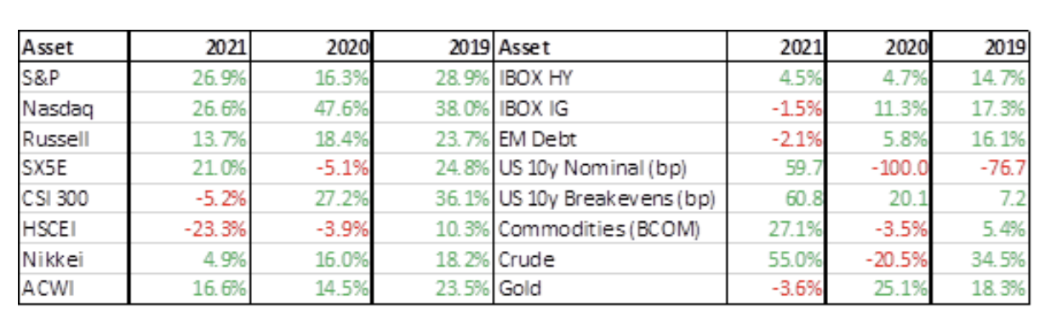  
However, it was not all smooth sailing for equity markets, as we experienced numerous internal and external shocks that threatened risk sentiment throughout the year and the S&P had 7 instances of 3-5% pullbacks.   
  
In January, we saw the explosion of retail trading activity in “Meme” stocks, as GME and AMC infamously challenged returns across a number of L/S hedge funds. The resulting fear of HF de-grossing spurred VIX to 37, its highest level of the year, and the significant rise in retail investor participation was one of the most prominent themes of 2021, which we will cover later in this piece.  
Throughout the year, there was a flurry of activity happening under the surface, with a historic level of factor/sector rotations. For example, by mid-March Small Caps were up nearly 20% vs NDX ~flat, which is rather staggering to consider, given that NDX eventually outperformed RTY by 13% at the end of the year.  
  
All of these dynamics were ultimately supportive for implied vols as the VIX averaged 19.7 across 2021, its 2nd highest measure over the past decade, while vol of vol was perpetually bid with the VVIX averaging 115.3, its 2nd highest level since the data goes back to 2007. If you isolate the 5 best yearly S&P returns since 2007, it’s clear to see the elevated levels of volatility in the 2021 bull market, illustrating the continued scar tissue from Q1 ’20, similar to what we saw in 2009 coming out of the GFC:  
  
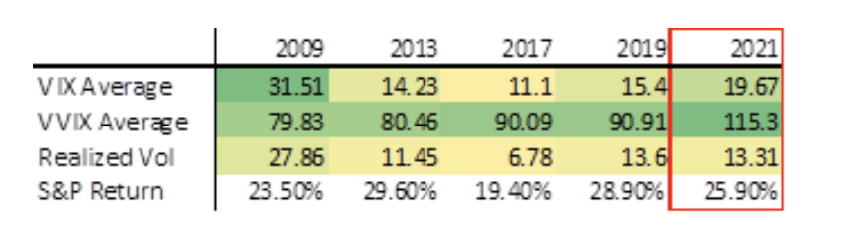Arguably even more dramatic than the moves in equities was the extreme amount of volatility in the rates world. UST 10yr yields jumped 60bps in 2021 and were completely driven by inflation expectations as 10yr breakevens experienced their largest annual increase since 2009.  
  
The surge in essentially every measure of inflation has forced the Fed to change their messaging, removing the notion of inflation being transitory and accelerating the pace of tapering/expected rate hikes. This has caused extreme moves along the yield curve evidenced by the 2y10y curve which, despite finishing the year roughly unchanged, spiked 78ps in Q1 (its 5th largest quarterly rise ever) and collapsed 43bps in Q4 (largest quarterly decline since 2012). These extreme moves helped spur option activity across the suite of Fixed Income ETFs, which has been a consistent theme over the past 5 years.  
  
*Throughout this piece, we will reflect on the impressive 2021 performance and analyze the key themes/dynamics that emerged across the global macro and volatility world in 2021:***Persistently steep S&P skew on the way to new all-time highs:**The S&P posted new all-time highs an incredible 70 times in 2021, the most since 1995. However, as mentioned above, implied vols remained elevated throughout the year as Covid fears loomed.  
  
Perhaps the best illustration of this heightened fear among investors is S&P 3m 90-100% downside skew, which spent most of 2021 near its steepest levels over the past decade.  
  
**S&P 3m 90-100% downside skew has remained near 10yr highs:**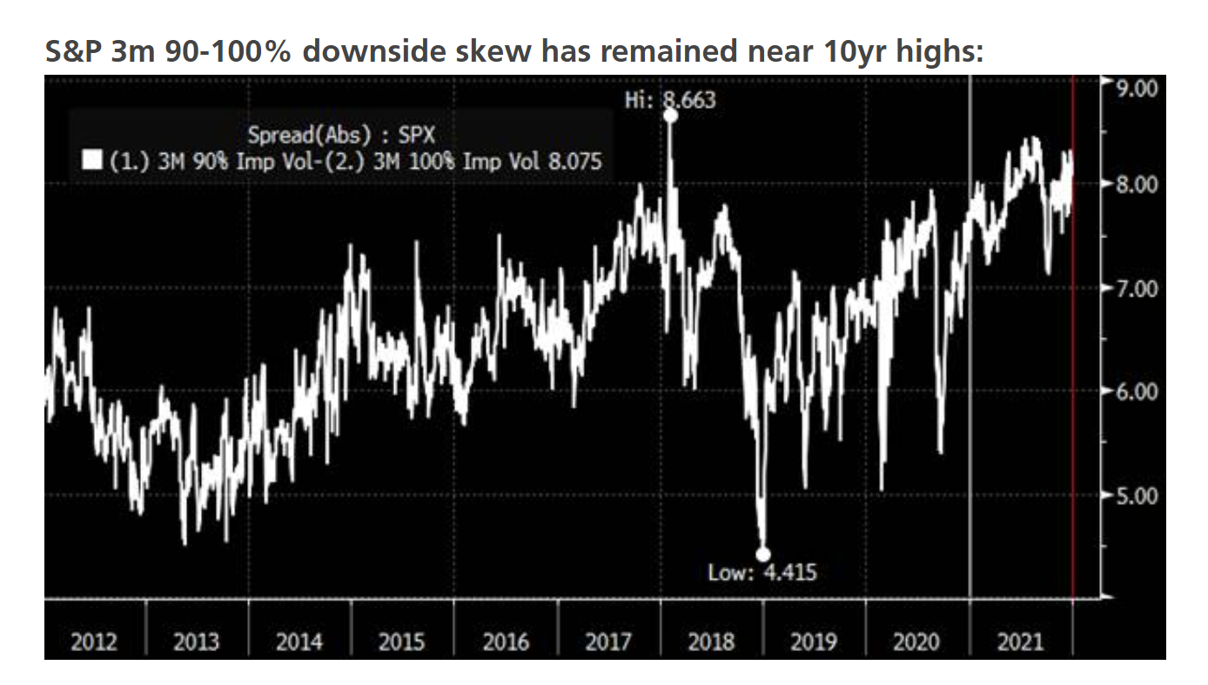  
  
There were few factors at play that likely contributed to the steep downside skew:

1. Significantly reduced activity from put underwriters and vol sellers given the carnage from Q1 ‘20
2. Plenty of macro headlines that resulted in heighten downside risks throughout the year
3. There were 7 instances of 3-5% pullbacks in ’21 amid a record number of all-time highs, keeping investors on their toes and worried about potential air pockets

The reluctance to sell volatility was particularly felt in the back-end of the S&P termstructure. In our 2020 Year in Review, we noted that the vol arb community, which predominately used S&P vol as the funding leg of relative value vol trades, either disappeared from the market or dramatically cut back risk.  
  
While we’ve seen a pickup in demand for short-dated vol selling, and a return of some relative value strategies, the supply on the back of the curve remains relatively non-existent, as can be seen in the S&P termstructure chart below, which shows 1y-2yr implieds closing out the year near the same levels as 2020, while short-dated implieds have fallen multiple points.  
 **S&P termstructure at year-end for last 3yrs shows bid to long-dated vols:**  
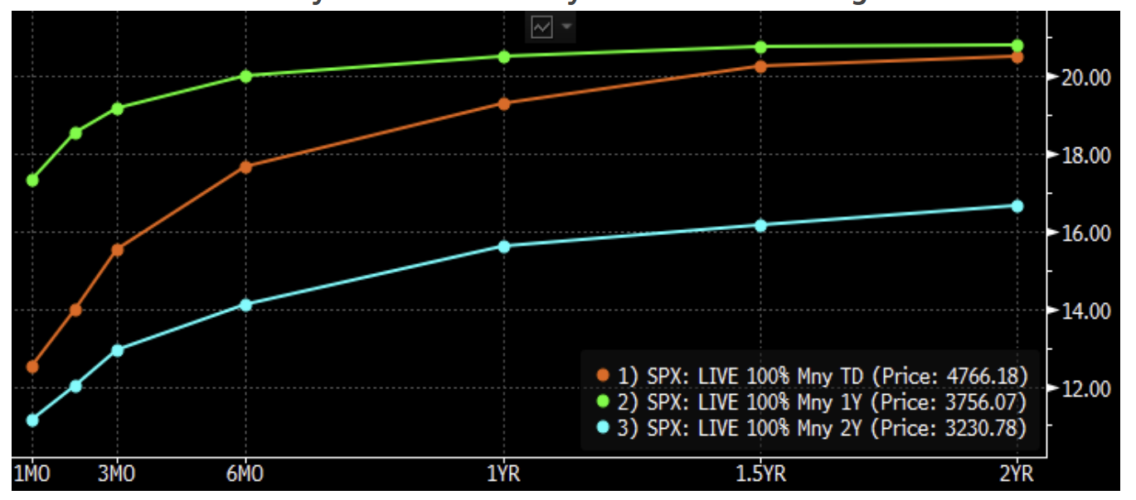  
 **Increase in dispersion trading across client types:**One of the most interesting dynamics across the volatility landscape in 2021 was the increase in dispersion trading across a wide spectrum of client types.  
  
As mentioned in the termstructure dynamics above, the shockwaves from Q1 2020 has left a void among the typical vol arb community who traditionally acted as a source of risk recycling for bank exotics desks needing to hedge vega and correlation risks on the back of retail structured product issuance.  
  
In 2021, both the absolute return orientated macro community and longer-term focused pension type clients saw this void as an opportunity to be a liquidity provider and use dispersion trades as a way to generate a source of absolute return in an overall low yield environment.  
  
The structure of these trades has also evolved, as the popular formats have shifted away from the traditional “top 50” dispersion to a custom basket approach to more precisely take advantage of vol dislocations on the back of dealer axes or to implement structures that have a fundamental/macro bend by playing for a particular thematic rotation across names (ie growth vs value, re-opening vs stay at home, etc).  
  
Learning from the 2020 aftermath where the net short SPX variance leg became a one-way pain trade, the trades in 2021 were often implemented in a more defensive format such as vega neutral (instead of theta neutral) to have a long vol bias or via geometric dispersion to limit the basis risk vs the short index leg. We also saw a sharp pickup in activity in global “pairwise dispersion” which has been trading at rather attractive levels due to increased structure product flows and is an efficient way for clients to isolate correlation exposure without having a long or short vega bias.  
  
We expect this interest in dispersion to increase heading into next year given the generally positive experiences thus far among new users. 2021 was an ideal backdrop for dispersion trades as realized volatility remained elevated while realized correlation across single stocks was particularly low due to the constant macro undercurrents that led to continued sector and factor rotations throughout the year:  
  
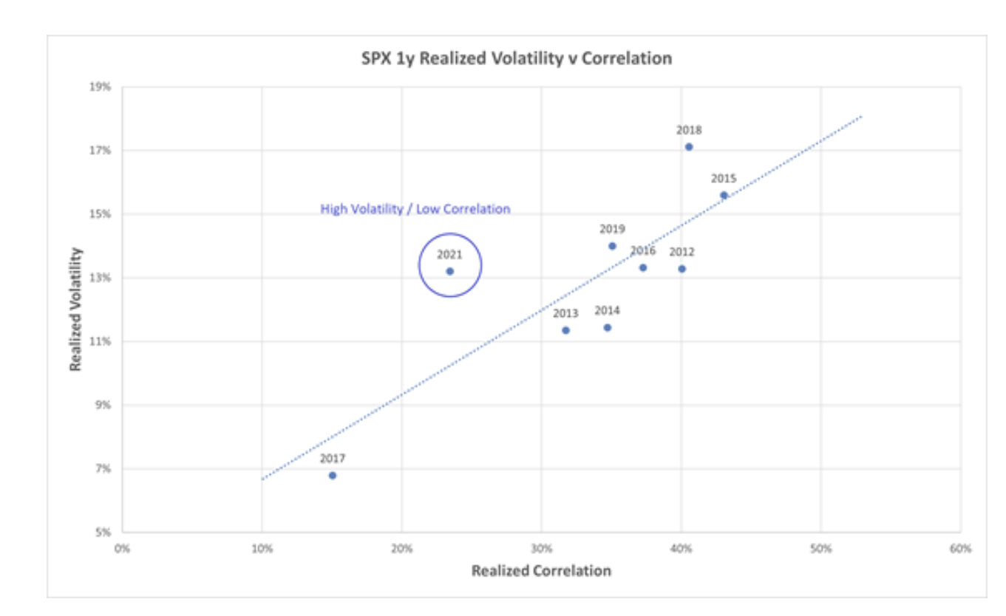  
  
**Moves beneath the surface - Tech remains a darling:**  
Winners kept on winning. As has been the case for the better part of the last decade, Tech remained an equity market darling. In particular, the largest names continued to lead the way as our Mega Cap Tech basket (UBXXMEGA) finished the year up another 33% and is up over 300% since 2018, registering as the best performing thematic basket over that period.  
  
There were a number of factors at play that continued to fuel the Tech rally:  
1) Real yields remained near historical lows:  
2020 was the perfect storm for Tech as stay at home dynamics and US real yields historically plunging to below -1% provided a massive tailwind. These low real yields remained intact throughout 2021.  
  
Bhanu Baweja (Chief Global Strategist) thinks there have been 2 major forces driving the depressed levels of real yields: 1) Supply/demand mismatch of TIPS and 2) Collapsing European real yields.The Fed’s purchases of TIPS dramatically flipped the supply/demand dynamics, as seen on the chart below. In 2021, such imbalances continued, albeit to a lesser extent, which helped keep real yields low.  
  
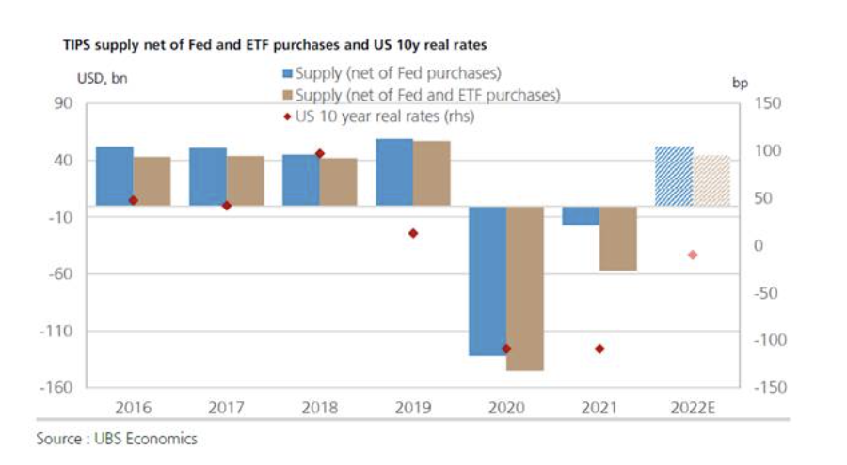  
  
Across the pond, German 10y real yields have fallen 70bps, putting pressure on US real yields given that the gap between US and EU yields has moved in a steady range net of FX hedging costs:  
  
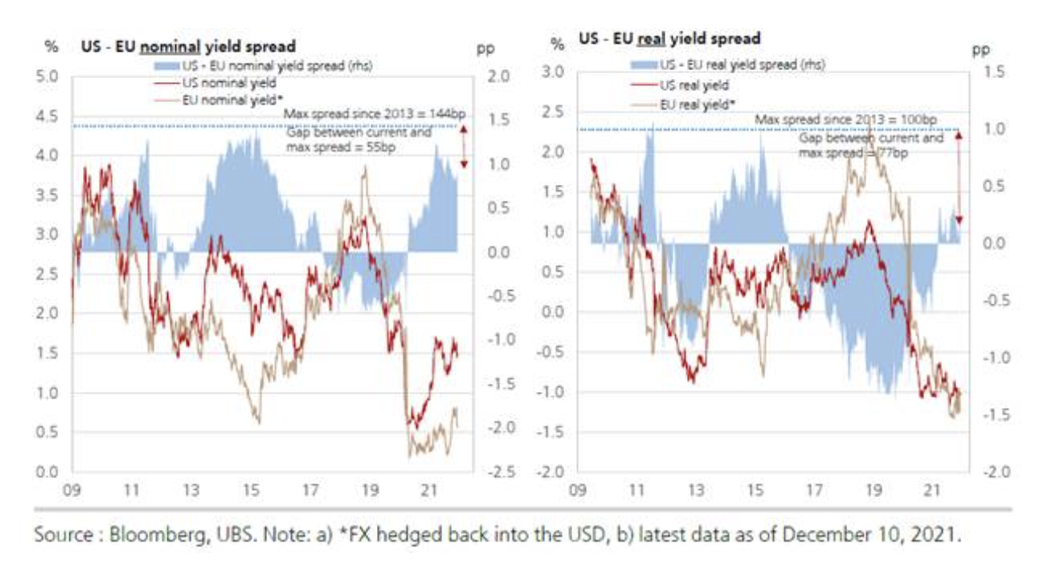  
  
However, in 2022, Bhanu expects both factors to reverse sharply. The supply of TIPS net of Fed purchases will likely flip from -$16B in 2021 to +$54B in 2022, which have already begun to show in ETF inflows. He also expects both European and US real yields to rise more than nominals through 2022 as inflation breakevens come down.  
  
These changes could see real yields rising ~100bps in 2022, which would be the 2nd highest increase in the last 2 decades behind the ‘taper tantrum’2013. Forward real yields have already started to reflect the turning tides, as seen in below chart: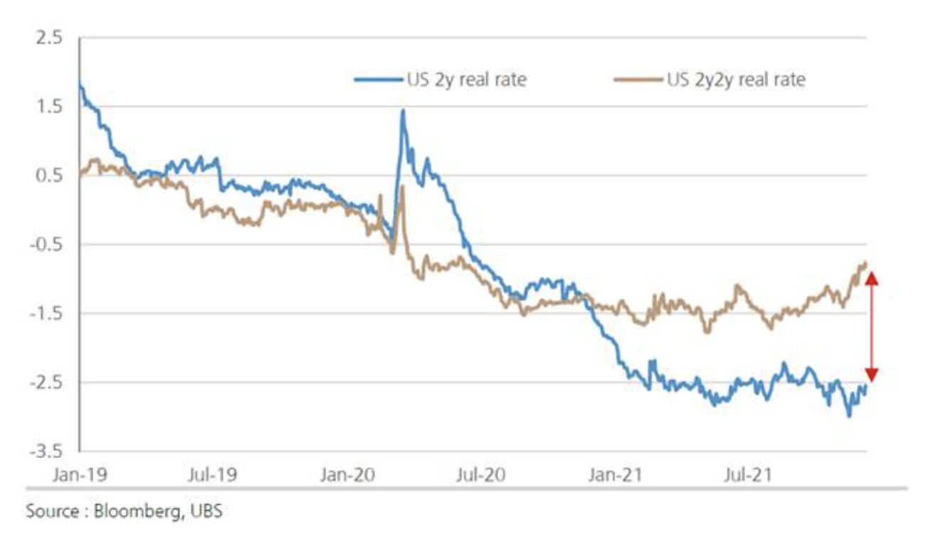If the UBS strategy team is correct, this rise in real yields could have negative impact particularly on EM equities, Semis, Tech Hardware, REITs, Consumer Durables, and Pharma. On the other hand, Financials, Utilities, and Transport should outperform.  
2) The rise of retail - explosion of retail investor activity likely added fuel to Tech rally:  
Another factor that was front and center amid the Tech rally was the surge in retail activity. You cannot look back on 2021 equity markets without examining the rise of the retail investor.  
  
As mentioned in the intro, the “Meme” stocks event in late-January illustrated the impact retail investors can have on single stock performance. The chart below shows the flows in our Retail Market Making (RMM) platform over the past 3 years, illustrating explosive growth in 2021.  
  
**UBS RMM flow shows consistent buying with growing volumes in 2021:**  
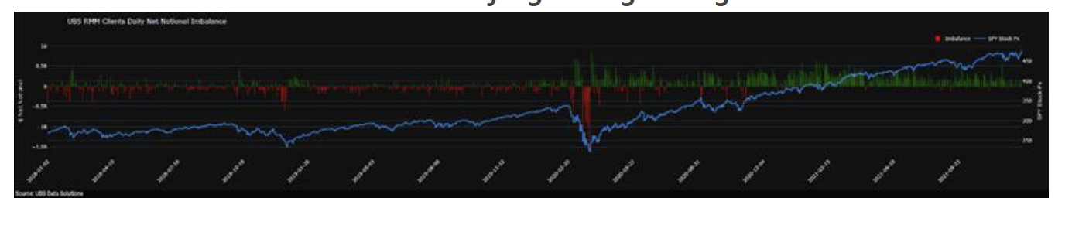  
  
The impact of retail was also felt in the options market. As retail investor platforms became more sophisticated, we have seen a significant spike in options trading activity from retail investors, impacting both spot prices and vol/skew dynamics across single stock names.  
  
Stuart Kaiser (Head of Equity Derivs Research) has done extensive work this year tracking retail options trading activity by analyzing option trades of 1-10 contracts in the market (typical retail footprint). Below charts show that a significant portion of the growth in retail activity came from call buying and these small size trades now account for ~20% of the total option volumes in the market.  
  
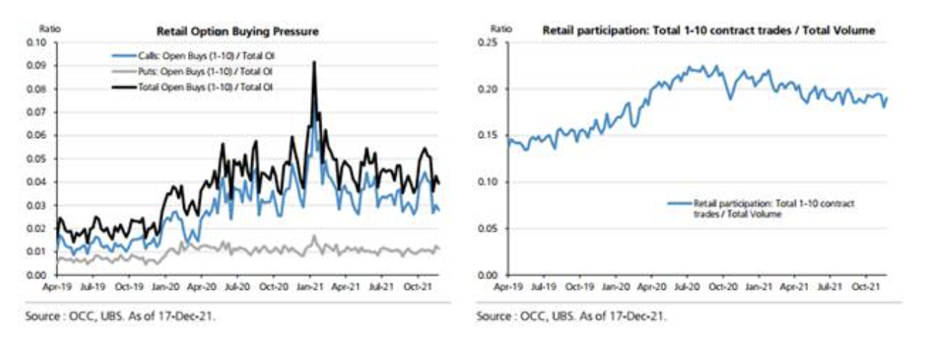  
  
On a broad scale, the rise of retail investor activity resulted in spiking single stocks option volumes. In 2021, single stocks daily avg option volumes were up ~37% YoY while index option volumes were up only ~6%. In particular, and perhaps unsurprisingly, the call volumes across “Meme” names exploded, which is shown below using our Meme basket (UBXXMEME) as proxy.

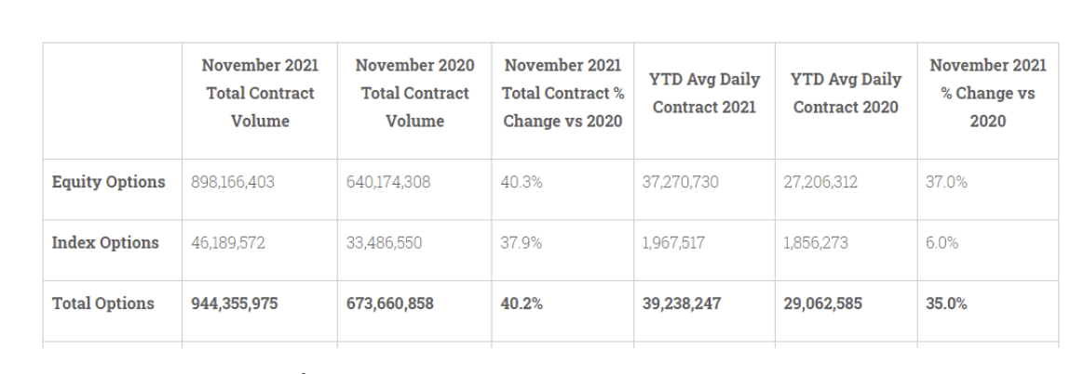  
Source: Option Clearing Corporation  
  
**Top 10 names within UBXXMEME basket listed option growth:**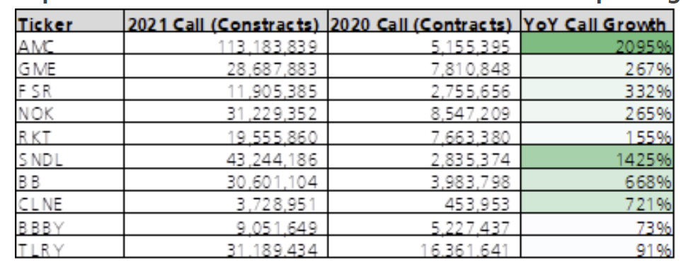  
  
On the index level, the strong and persistent Tech performance was met with a slew of option activity as NDX and QQQ call volumes were up ~2x and ~45% YoY, respectively. As a result, and contrary to elevated S&P downside skew, Nasdaq upside skew remained persistently flat throughout the year on the back of this continued upside buying.  
 **NDX 1m 100-110% upside skew remained flat all year from continued call buying:**  
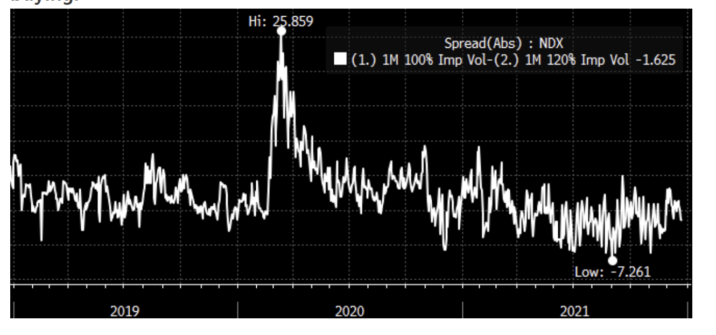 **The Fed and inflation – how it impacted equity markets:**As discussed above, surrounding the impact of real yields on Tech, the path of global central banks was among the most prominent themes in 2021 that drove equity and cross asset performance.  
  
In the US, the Fed kept its accommodative stance through must of the year, despite the sharp economic recovery and rising inflation. Given surging energy prices and supply bottlenecks, CPI skyrocketed 6.8% in the November report, its sharpest spike since 1982. Inflation expectation ran hot throughout the year with 10y breakevens reaching as high as 2.75% and closed out 2021 up 61bps for its largest annual spike since coming out of the GFC in 2009.  
  
Unsurprisingly, this inflationary pressure had a substantial impact on equity performance under the surface, evidenced by our inflation beneficiaries basket (UBXXINFL) being the best performing thematic basket of the year, up 39.6%. Inflationary sensitive sectors all performed incredibly well with Energy +47.7% (best yr EVER), REITs +42.5% (best yr EVER), and Fins +32.5% (best yr since ’13).  
  
Unfortunately, 2021 was also the year where precious metals stopped working as an effective inflation hedge. In our previous 2 yearly recaps, we highlighted precious metals’ consistent performance through low real yields, unstable macro backdrop, and rising inflation expectation, however, in 2021 this relationship broke down as both Gold and Silver finished the year down -3.6% and -11.7%, respectively.  
  
As a result, we saw a sharp decline in options activity across the precious metal contingent as GLD and SLV volumes were down ~50% and ~20% YoY. This is a staggering contrast to 2020 where we saw ~90% and ~220% increases in option activity.  
  
For clients looking for Gold exposure in 2022, consider the UBS Gold Range Accrual strategy (XUBSPGRA) which is systematically long physical gold vs short a daily traded 2m 95-107.5% strangle. This provides long gold exposure while also generating addition yield from the premium harvested by taking advantage of the consistent Gold implied vs realized vol risk premia. The strategy has outperformed outright Gold an avg of 5% per yr since 2008.  
  
Shifting gears back to equity sectors, investors focused their option trading attention on the inflation sensitive parts of the market. Sectors such as Financials, Materials, and Energy remain correlated to inflation and experienced YoY call volume growth of ~25%, ~60%, and ~100%, respectively. Energy, in particular, had additional kicker from the reopening theme, which we’ll discuss in a later section.  
  
Meanwhile, we saw another “asset class” emerge as potential inflation hedge: crypto currencies. We continued to see explosive growth in the crypto market, highlighted by the first ETF tied to Bitcoin futures (BITO), which began trading in October, and within a month the ETF’s market cap grew well over $1B.  
  
However, Bhanu Baweja (Global Chief Strategist) noted that while there was a firm price relationship was established between Bitcoin and inflation expectations, it was largely driven by risk appetite, rather than inflation. He expects that if higher inflation expectations result in lower equities in 2022, it is very unlikely that Bitcoin will continue to rally. *Read the Report*…[15 Essential Charts: When tighter liquidity & weaker growth collide](https://neo.ubs.com/shared/d2ADBQ7xRlahsRK)  
  
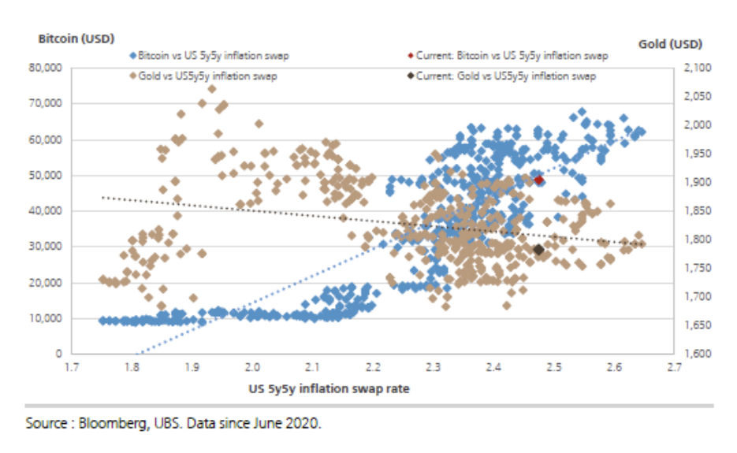  
  
As for the path ahead for inflation, UBS Econ team expects inflation to remain elevated in the near-term, before falling sharply starting in late 1Q22. Their forecast for 2022 PCE of 1.8% is materially below consensus and a bit below the FOMC’s 2.0% inflation target, which could dampen the focus on inflation next yr. *Read the Report*…[US Inflation Monthly: A few more months of strength](https://neo.ubs.com/shared/d2g0eORxmR8Gv)  
  
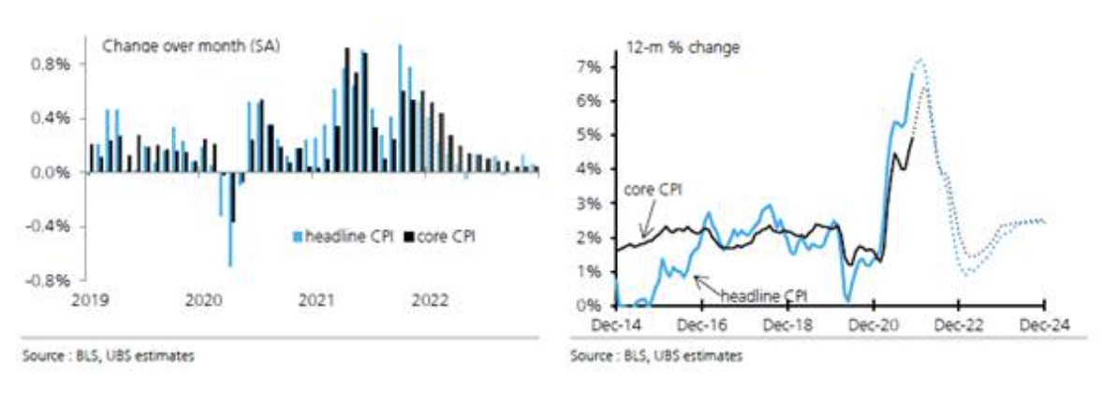  
  
**Increased interest in both Commodity beta and risk premia:**  
On the back of the inflation impulse, we saw a slew of activity across the commodity contingent.  
  
Due to the confluence of factors such as surging global growth and inflation dynamics, the BCOM index rallied 27% for its best yearly performance since 1979.  
  
As a result, we have seen both HF and asset owner clients look to add commodity beta exposure to their portfolios. In particular, we have helped a number of clients replace their vanilla BCOM exposure with our UBS BCOM Constant Maturity Index (CMDJCITR), as a more efficient implementation of benchmark Commodity exposure.  
  
It's a rather simple/intuitive strategy, in that it uses the same weights as the respective BCOM benchmark, but takes positions across the liquid parts of the futures curve, while not concentrating on the front part of the curve, aiming to reduce the problems of negative roll yield while maximizing tracking to underlying spot prices.  
  
Given these dynamics, the UBS BCOM Constant Maturity Index was up 31% in 2021 and has outperformed BCOM in every year since the index has been live going back to 2007.  
  
In particular, the strategy has outperformed the most in tail environments, both in the extreme negative and positive scenarios. As a result, in global growth shock periods, like Q1 2020, the CM-BCOM profile offers a defensive tilt vs BCOM while the rest of a cross-asset portfolio is potentially under pressure:  
  
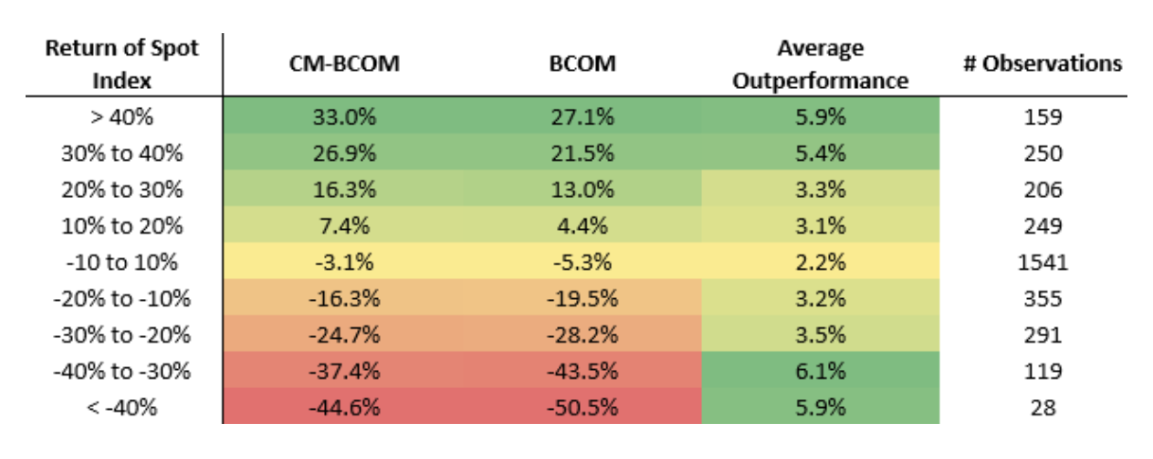  
  
We have also seen clients look to use Commodity Risk Premia as a source of absolute return amid the overall low yield environment.  
  
Utilizing the Commodity beta dynamics mentioned above, clients have accessed Commodity carry through our COSIER Index, which goes long the UBS BCOM Constant Maturity Index vs short BCOM. COSIER was up 2.8% in 2021 amid the Commodity bull market, while also rallying 6.2% in 2020 and has been positive every year since its inception in 2007.  
  
Interestingly, given COSIER’s negative beta to the market in riskoff periods (+8.7% in ‘08 & +5% in Q1 ’20) and overall absolute return/positive yield profile, we have seen credit investors add the strategy as a diversifier to their IG and HY portfolios.  
  
More broadly, we have seen continued interest in our UBS Commodity Risk Premia Portfolio (XUBSRPVP) which is a diversified basket of our highest conviction Commodity RP strategies across Commodity carry, value, and scarcity. The strategy was up another 6% in 2021 following a gangbusters +20% performance in 2020, while exhibiting an 11.5% avg annual return and 2.1x Sharpe since 2002.  
  
**Elevated equity/bond correlation & ineffective credit hedges**:  
  
Keeping our focus on cross-asset dynamics, one of the most concerning developments was the surge in equity/bond correlation, which put pressure on multi-asset portfolios that rely on the typical diversifying profile of bonds.  
  
Persistent asset purchasing by the Fed amid the strong equity rally contributed to 12m S&P/UST 10yr bond correlation turning positive on several occasions throughout the year. There were only 4 other instances since 1999 where 12m correlation turned positive, which illustrates the unique backdrop in 2021 and is something to watch closely heading into 2022. This phenomenon was flagged by both Rebecca Cheong (Head of US Derivs Strategy) and Stuart Kaiser (Head of Eq Derivs Research) as a potential downside risks as a result of cross-asset risk reduction.  
  
**12m equity/bond correlation turned positive in July and Nov:**  
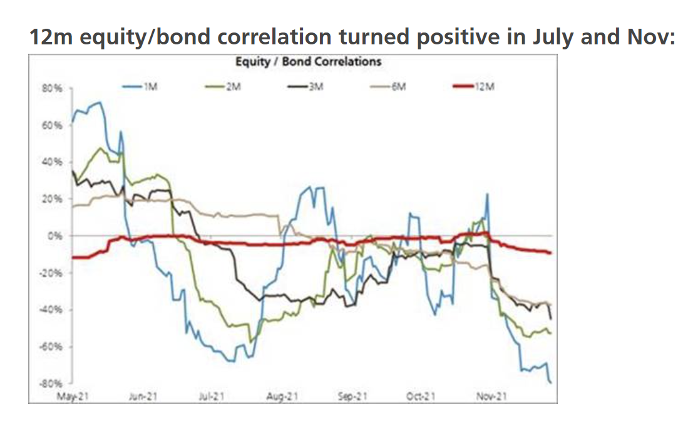Continued focus on cross-asset dynamics spurred yet another year of growth in Fixed Income ETF option usage. Both Treasury (TLT/IEF) and IG (LQD) linked ETF options grew at a steady pace, up ~20-40% across the board.  
  
The one exception to this trend was High Yield (HYG) where option volumes decreased slightly YoY, partially due to the record volumes seen in 2020. However, the ineffectiveness of HY as a downside hedge during bouts of equity volatility was likely another factor that contributed to the reduced option volumes.  
  
HYG implied vols were the definition of a value trap. They were extremely low throughout 2021 and 3m ATM IV closed the year near 10yr lows, however, HYG realized vol for 2021 was a paltry 4v, also representing 10yr lows and resulted in hedges that rarely paid. Also, while HYG ATM vols are extremely low, similar to the S&P skew dynamics, HYG tails are very bid as HYG 3m 90-100% downside skew currently sits at its highest 93rd-%ile over the past decade.  
  
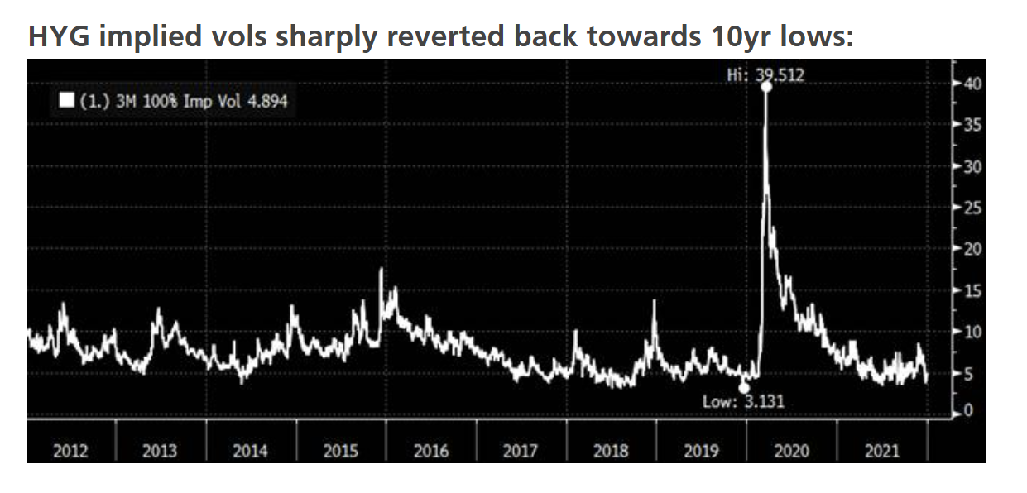 **COVID Year 2 – Reopening trades:**Unfortunately, Covid remained a dominate theme in the market as 2yrs of mutating variants has had varying impacts on parts of the market. As Omicron continues to spread, it appears that this is reality for the foreseeable future.  
  
Much of 2021 can be characterized by a the lack of conviction around the reopening theme. While our Reopening basket (UBXXOPEN) outperformed Stay at Home (UBXXSTAY) by 13.9%, both baskets significantly trailed the S&P and took a rather volatile path throughout the year:  
  
**Stay at Home (UBXXSTAY) and Reopening (UBXXOPEN) monthly performance in 2021:**  
  
  
The back and forth reopening sentiment ultimately hurt Small Caps as the Russell underperformed the S&P by 13.2%, its largest annual underperformance since 1998. Small Caps experienced rather extreme gyrations, only trading in a ~18% range since Feb, however, experienced 8 selloffs of greater than 5% along the way, before closing out the year right at its respective 100/200dma.  
  
**RTY had peak to trough of 17.7% since Feb with strong support level at 2100:**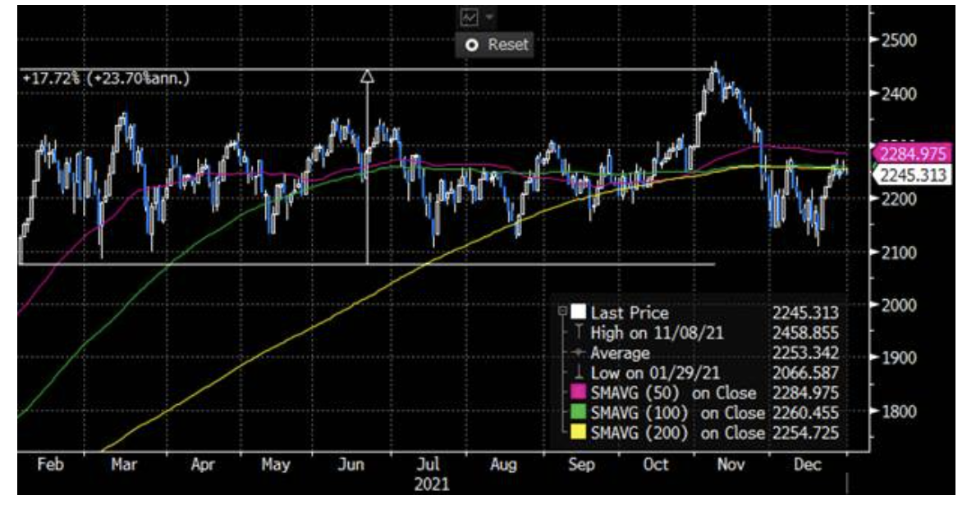The nervousness and uncertainty around Small Caps was reflected in the implied vol surface as the Russell vs Nasdaq implied spread remained elevated through the year.  
  
**RTY vs NDX 3m ATM IV spread stayed elevated throughout 2021:**  
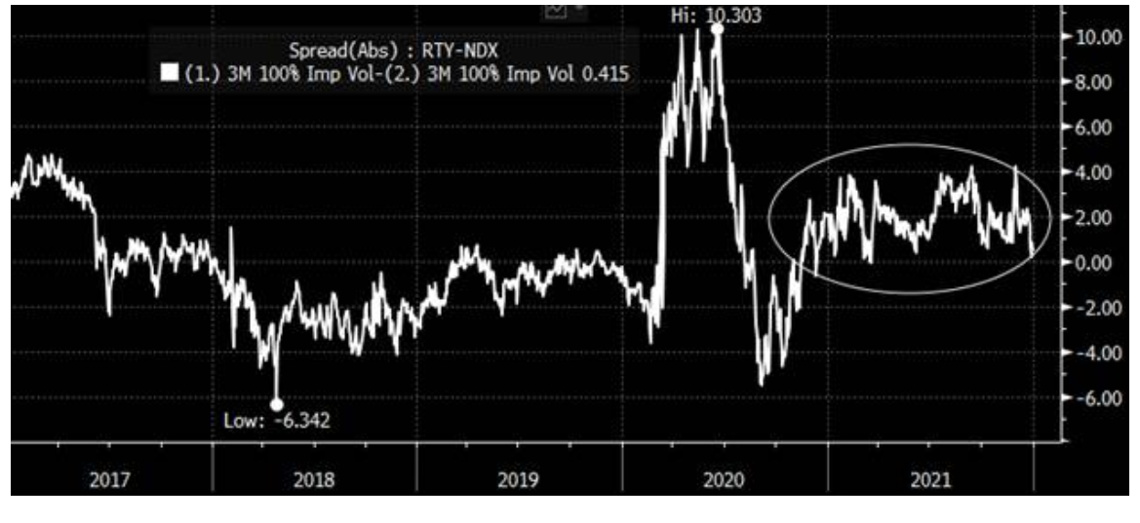  
  
On the other hand, one area within the reopening theme that consistently performed throughout the year was Energy, as the sector finished the year up 47.7% for its best year ever. Crude skyrocketed towards $85/barrel in October with global demand bouncing back and inventories falling to pre-pandemic levels as the supply response from producers was weaker than expected.  
  
Energy sector (XLE) call volumes surged ~2x as clients chased the rally and was exacerbated by multi-year underweight positioning in the sector. This explosion in upside interest was also felt on the Energy single stock level as the most popular names saw call volume growth significantly outpace demand for puts:  
  
**Top 5 Energy names seeing significant call option volumes increase YoY: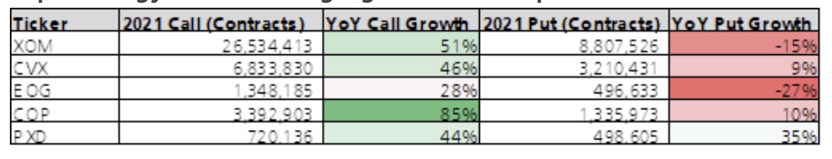 APAC equity option trading during US hours:**In 2021, we also saw an increased interest among US clients to trade ex-US country ETF options, particularly in the APAC region.  
  
China – regulatory pressure and property shockwaves:  
  
As shown in the performance grid in the intro, one of the few markets that finished in the red was China. The country tightened its regulations across the Tech industry for monopolistic behavior, resulting in massive fines and increased control over some of the largest e-commerce and entertainment companies. If regulations weren’t enough, the Evergrande situation sent shockwaves through its property market and further negatively impacted risk sentiment.  
  
Given the confluence of negative factors, the CSI300 and HSCEI finished the year down 5.2% and 23.3%, respectively. The China Internet was hit particularly hard with the China Internet ETF (KWEB) down 52.5% for its worst year ever.  
  
Interestingly, in the options space, we saw YoY decreases in activity across EEM and FXI as volumes were down ~20%. On the other hand, we saw more isolated buy the dip activity in the China Internet sector as KWEB call volumes were up over 600% YoY.  
  
Looking ahead, our China equity strategy team is now overweight China Internet as he believes we are at the tail end of this regulatory cycle and positioning looks heavily skewed on the short side. *Read the Report…*[China Equity Strategy - Outlook 2022: Climbing out of a dip](https://neo.ubs.com/shared/d2Xrex0Nnv)  
  
**China internet sector P/E and short selling turnover:**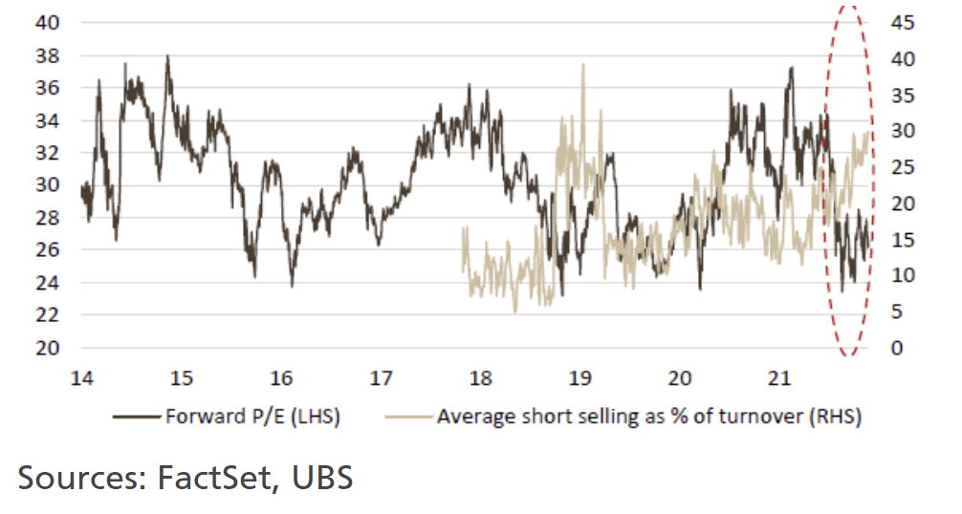Sources: FactSet, UBS  
  
Japan – leadership change supporting outperformance:  
  
On the other hand, Japan outperformed its APAC peers as the TOPIX rallied 10.4%, while MSCI Asia ex-Japan was down 6.4%. The change in leadership to PM Kishida was received positively with increased expectations for stimulus which has caused JPY to weaken against the Dollar for the first time in 6 years, adding a tailwind for equities. Our Japan Chief Economist, Masamichi Adachi, has raised his 2022 year-end TOPIX target to 2,140, reflecting another ~7% upside.  
  
Option market activity reflected a bullish sentiment in Japan with EWJ call volumes up ~2x while put volumes were down 40% YoY, reflecting lopsided upside vs downside expectations for a Japan ‘catch-up’ rally. Interestingly, almost 20% of the call volumes for the entire year traded in September, positioning for the typical 4Q positive seasonality which failed to materialize as EWJ actually fell 4.7% in Q4.  
  
It’s also surprising to note that the majority of the activity was in EWJ rather than the currency hedged DXJ ETF which saw call volumes collapse 60% YoY. Given the diverging monetary policies across the BoJ and the Fed, the currency component is an extremely important element of the trade and was reflected in the fact that DXJ outperformed EWJ by 15.8% in 2021, its largest such annual divergence since the ETF was launched in 2007. If you are bullish Japan, and that view is predicated on a weaker JPY, upside exposure should be expressed in DXJ over EWJ.  
  
**UBS outlook for 2022 from our thought leaders:**2022 will likely bring more challenges for the US economy following such a strong recovery in 2021. Jonathan Pingle (US Head Economist) expects GDP growth to slow from 5.4% to 3.9% in 2022.  
  
As mentioned earlier, our econ team also expects core PCE inflation to peak in Q1, then sharply decline thereafter, ending 2022 at 1.8%. On the other hand, employment is expected to continue improving and reach pre-pandemic levels during Q3 2022.  
  
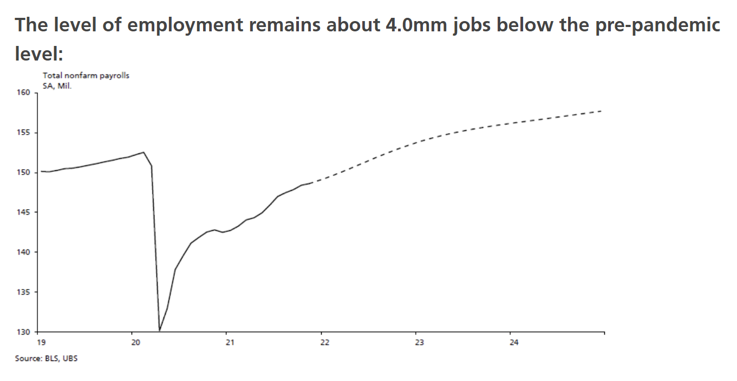  
  
This stabilizing US economic backdrop will push the Fed to start tightening their monetary policy and reduce the size of its balance sheet in 2022, which could result in a potential headwind for equity markets.  
  
Meanwhile, the Omicron variant continues to pose a threat. Both cases and hospitalizations are on the rise and leading to renewed lockdowns which has challenged global mobility, representing a looming headwind that should be to closely monitored.  
  
**Omicron cases and hospitalizations on the rise:**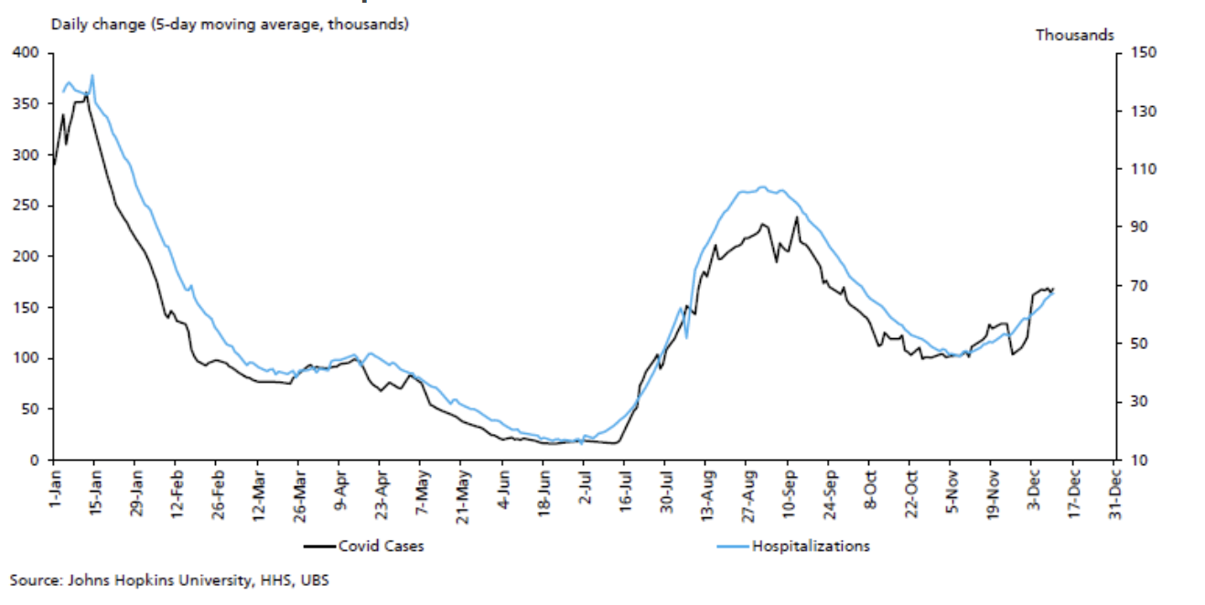  
  
As for monetary policy, FOMC participants’ median 2022 assumption sits at three hikes for the year, with the labor market achieving maximum employment representing the last prerequisite for liftoff. Our view is that the Fed will remain patient in its pace of rate hikes, starting in late 2022.  
  
**Our base case roughly fits FRB rules:**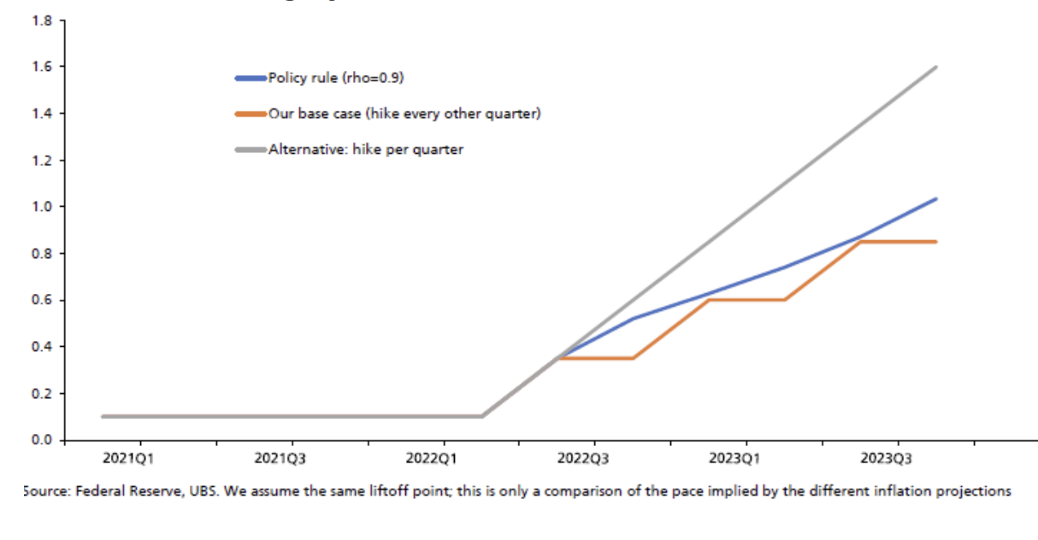  
  
While the economic backdrop will likely become more challenging, our strategists remain bullish in the near-term. Keith Parker (Head of US Equity Strategy), while noting that the pace of rate hikes and the Omicron variant remain an underlying concern, Keith expects the S&P to reach 5000+ in 2Q22, as a 13% rise in forward EPS will more than offsets a ~5% headwind from tighter financial conditions. In the 2nd half of the year, however, he expects EPS downgrades amid tighter financial conditions which puts his 2022 year-end S&P target at 4850. *Read the report…*[US Eq '22 Strategy: earnings vs Fed vs variant](https://neo.ubs.com/shared/d2sSJuDqsv)  
 **Keith Parker’s 2022 S&P expectations summary:**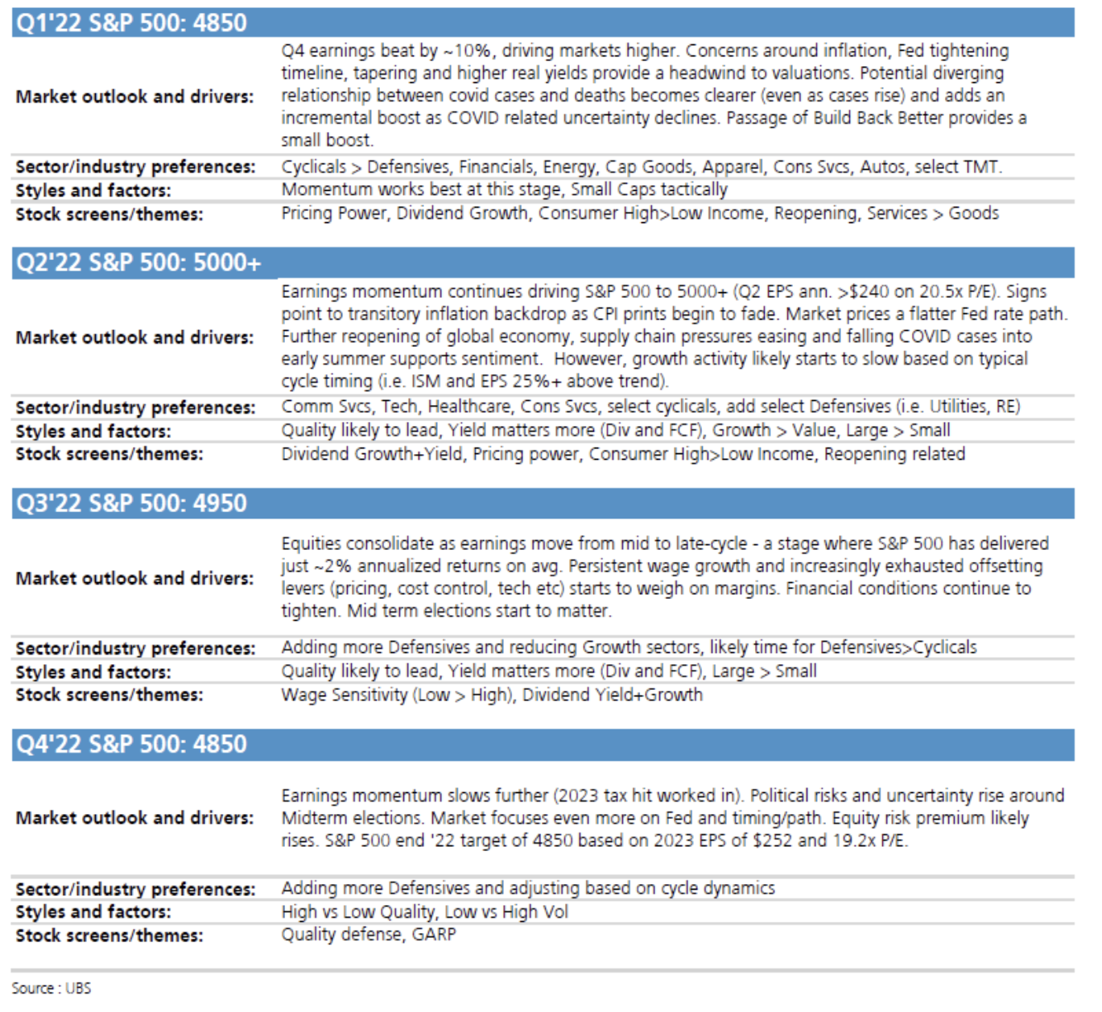  
  
Rebecca Cheong (Head of US Derivs Strategy) echoes these near-term bullish expectations from a market internals perspective. Risk Control and CTA funds both have relatively low exposure given the recent market volatility, leaving room for these funds to add exposure in early 2022, while falling equity/bond correlations in December is a favorable tailwind for Risk Parity and multi-asset investors to add overall exposure due to improving diversification characteristics.  
  
UBS PB L/S fund gross leverage is very low, currently sitting at its lowest 11th-%ile over the past 3yrs, while net leverage is at its lowest level since Feb’13, providing another potential investor community who has room to add exposure.  
  
All of these in internal factors, combined with consistent retail buying support, should be supportive for near-term equity performance.  
  
*We appreciate the continued partnership and look forward to engaging in an active dialogue in 2021.*  
  
*Wishing you and your family a wonderful and healthy New Year!*Davide Montoni & Nori Shimizu

**Davide Montoni**US Head of QIS and PEF Sales  
  
**UBS Securities LLC**  
1285 Avenue of the Americas  
New York, NY 10019  
Office: 203-719-7900  
Mobile: 203-305-9633  
Work Mobile: 917-304-3163  
[davide.montoni@ubs.com](mailto:davide.montoni@ubs.com)  
  
*\*\*Sales & Trading Commentary Only**  
For Institutional Investors Only*  
*Not a Product of UBS Research*